# Question 10.1

## Code

% Q10.1

clc

clear all

A=[1 3 5]

B=[-3 -2 4]

part_a_Left=A.*B

part_a_Right=B.*A

A=[0 -1 -4 -8]

B=[4 -2 -3 24]

part_b_Left=dot(A,B)

part_b_Right=dot(B,A)

## Output

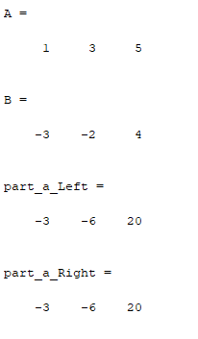

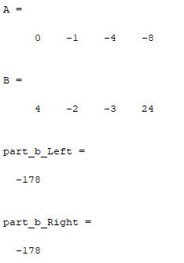

# Question 10.7

## Code

% Q10.7

clc

clear all

A=[12 4;3 -5]

B=[2 12; 0 0]

part_a_Left=A*B

part_a_Right=B*A

A=[1 3 5; 2 4 6]

B=[-2 4;3 8; 12 -2]

part_b_Left=A*B

part_b_Right=B*A

## Output

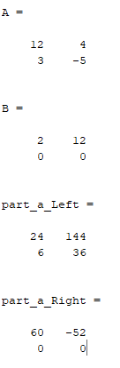

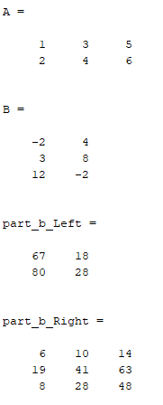

# Question 10.14

## Code

clc

clear all

% Q10.14

A=[2 -1; 2 5]

[r c]=size(A);

if (r-c==0)

det_A=det(A)

else

disp('matrix is not square')

end

if(det_A==0)

disp('A Has No Inverse')

else

inv_A=inv(A)

end

B=[4 2; 2 1]

[r c]=size(B);

if (r-c==0)

det_B=det(B)

else

disp('matrix is not square')

end

if(det_B==0)

disp('B Has No Inverse')

else

inv_B=inv(B)

end

C=[2 0; 1 2; 5 -4]

[r c]=size(C);

if (r-c==0)

det_B=det(C)

else

disp('matrix is not square')

end

if(det_B==0)

disp('C Has No Inverse')

else

inv_C=inv(C)

end

## Output

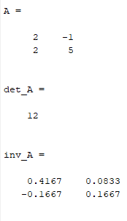

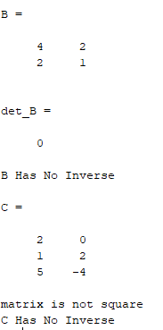

# Question 10.18

## Code

% Q10.18

clc

clear

A=[-2 1;1 1];

B=[3;10];

part_a_inv=inv(A)*B;

disp('Inverse Method')

x=part_a_inv(1)

y=part_a_inv(2)

part_a_div=A\B;

disp('Matrix Left Division')

x=part_a_div(1)

y=part_a_div(2)

A=[5 3 -1;3 2 1; 4 -1 3];

B=[10;4;12];

part_b_inv=inv(A)*B;

disp('Inverse Method')

x=part_b_inv(1)

y=part_b_inv(2)

z=part_b_inv(3)

part_b_div=A\B;

disp('Matrix Left Division')

x=part_b_div(1)

y=part_b_div(2)

z=part_b_div(3)

A=[3 1 1 1;1 -3 7 1;2 2 -3 4; 1 1 1 1];

B=[24;12;17;0];

part_c_inv=inv(A)*B;

disp('Inverse Method')

x=part_c_inv(1)

y=part_c_inv(2)

z=part_c_inv(3)

w=part_c_inv(4)

part_c_div=A\B;

disp('Matrix Left Division')

x=part_c_div(1)

y=part_c_div(2)

z=part_c_div(3)

w=part_c_div(4)

## Output

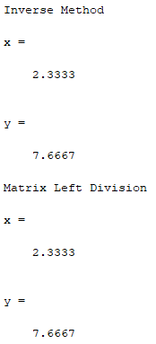

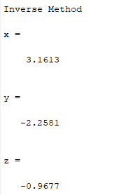

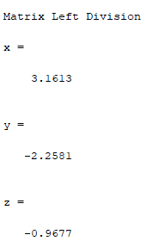

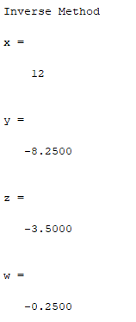

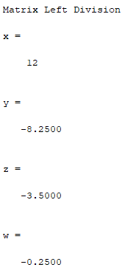

# Question 10.15

## Code

% Q10.15

clc

clear all

r = [10 10*sqrt(3) 0];

F = [0 -200 0];

M = cross(r,F)

## Output

